$$Statistics-9$$

$what is statistics$

$Data types$

$Levels of data$

$Population vs samaple$

$Inferential statistics and Descriptive statistics$

$Frequency table$

$Bar chart$

$Pie chart$

$Relative frequency$

$Frequency distribution table$

$Hitogram$

$Distribution plot$

$Central tendency$

$Mean -Median-Mode$

$Mean vs Median$

$Outliers , skew ness$

$Meaning of mode in data distribution$

$Types of skew ness$

$Postive-Negative-No skew$

$Normal distribution$

$Asymptodes$

$data dispersion$

$Range : Not cover middile values$

$Mean deviation: Total deviation zero$

$AMD: Discontinue at point zero$

$Variance: values and units are raised$

$Standrad deviation$

$Empirical rule : 68-95-99.7$

$Chebyshev inequality$

$Covariance$

$Covariance matrix$

$Correlation coefficient$

$Quartile-Percentile-Decile$

$out lier analysis$

$Box plot$

$$How to treat the Outliers$$

$$Dealing Outliers:$$

$$Outliers impact the mean not Median$$

$$Drop the outliers$$

$so if any outliers are present , we can drop the outlier$

$if the outlier has 2\% of data$

$suppose a data has 100 observations in that 2 observations consider as outlier$

$so outlier percentage is 2\%$

$if you drop 2\% of data then we have 98\% of data available$

$it is enough to train the ML model$

$$drop the outliers generally not recommended,$$

$$if we drop the outliers means we are droping the information of other columns also$$

Age Gender Income Cr

30 M 500cr good

$$Fill with median(50 percentile value) value:$$

$$As we know that, outliers does not affect by Median$$

$$so it is good practice we can fill outliers with median value$$

$$Fill with Q_{3} and Q_{1} \left(Cap the values\right):winsorization$$

$$what ever the outliers having more than Q_{3} fill with Q_{3} value$$

$$what ever the outliers having less than Q_{1} fill with Q_{1} value$$

$Drop the outliers$

$Fill with median$

$Cap the values with Q1 and Q3$

$$Scale the data$$

$$Generally in the data we have different types of columns$$

$$these columns has different type of values$$

$$some column has huge values , some columns has less value$$

$$also every column has different units$$

$$Why it is impact:$$

$assume that age=20 income=50,000$

$Some ML models think more value means more important$

$Some ML modles based in distance calculation$

$\left(x_{1},y_{1}\right) \left(x_{2},y_{2}\right)= \sqrt{{\left(x_{2}-x_{1}\right)}^{2}+{\left(y_{2}-y_{1}\right)}^{2} }$

$d\left(\left(20,50000\right),\left(30,20000\right)\right)takes huge computations$

$Interpreation of different columns not happen properly$

$$Compuations are easy$$

$$we can make all the columns as equal important$$

$$the qunatity of the data will be change, but qulaity \left(meaning\right)of the data not change$$

$$on earth my weight=60kgs=====MOON=6kgs$$

$$but mass is same$$

$$because we not only doing for one column, we will apply the same logic for all the columns$$

$$There are two types of scaling$$

$Standardization : Z-score$

$Normalization :MinMaxScalar$

$$empirical rule: 68-95-99$$

$u-1σ=x$

$$-1=\frac{x-u}{σ}$$

$u+1σ=x$

$$+1=\frac{x-u}{σ}$$

$u-2σ=x$

$$-2=\frac{x-u}{σ}$$

$u+2σ=x$

$$+2=\frac{x-u}{σ}$$

$u-3σ=x$

$$-3=\frac{x-u}{σ}$$

$u+3σ=x$

$$+3=\frac{x-u}{σ}$$

$$z=\frac{x-u}{σ}$$

$$z=\frac{x-u}{σ} the values ranges from -3 to 3$$

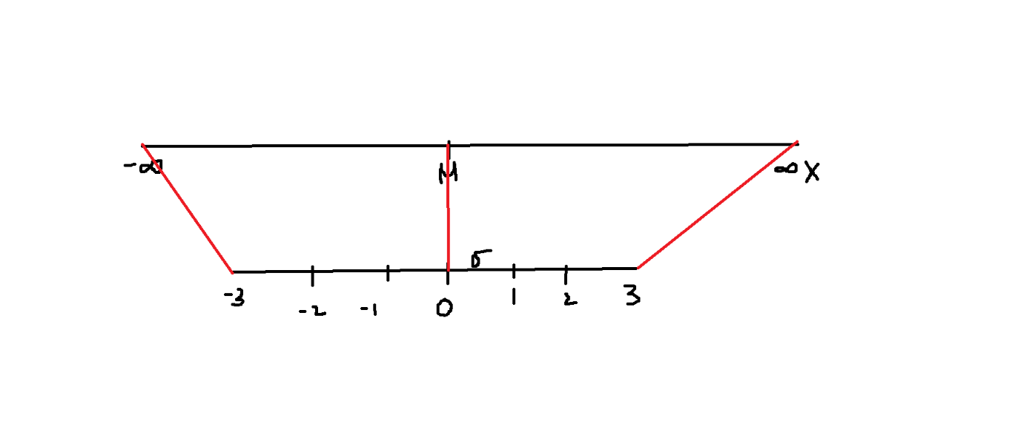

$$orignal data has-\inf{(min) to \inf{(\max{)}scale }}$$

$$when we converted into z-values the range become-3 to 3$$

$$30,31,32,33,34==== >Mean=32$$

|  |  |  |  |
| --- | --- | --- | --- |
| X | $$x-u$$ | $${\left(x-u\right)}^{2}$$ |  |
| 30 | 30-32=-2 | 4 |  |
| 31 | 31-32=-1 | 1 |  |
| 32 | 32-32=0 | 0 |  |
| 33 | 33-32=1 | 1 |  |
| 34 | 34-32=2 | 4 |  |
|  |  | 10= root(2)= 1.4 |  |

|  |  |  |
| --- | --- | --- |
| X |  | z |
| 30 |  | $$\frac{30-32}{1.4}=-1.42$$ |
| 31 |  | $$\frac{31-32}{1.4}=-0.7$$ |
| 32 |  | $$\frac{32-32}{1.4}=0$$ |
| 33 |  | $$\frac{33-32}{1.4}=0.7$$ |
| 34 |  | $$\frac{33-32}{1.4}=1.42$$ |

$$[-1.42,-0.7,0,0.7,1.42]$$

$$var\left(x_{z}\right)=cov\left(x_{z},x_{z}\right)=1$$

$$After performing standrdization if mean=0 and stnadrd deviation=1 this is called$$

$$standard normal distributon$$

$$Normalization: Min\max{scalar}$$

$$Normalization=scale is from 0 to 1$$

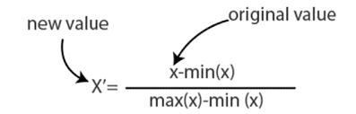

$$28,29,30,31,32$$

$$new_{x}=\frac{X-X_{min}}{X_{max}-X_{min}}$$

$$Normalization used for Image data( Neural networks)$$

$$Standardization is used for tabular data$$